Table of Contents
The Business Context 3
User Stories 4
Customer 4
Employees 4
Owners 5
Empathy Maps 6
Customers 6
Thinks 6
Says 6
Does 7
Feels 7
Functional and Non-functional Requirements 8
Functional Requirements 8
Non-functional Requirements 8
Hierarchy Diagram 9
Decomposition of Potential Problems 10
Creating the solution 10
Layout 10
Viewing Articles 10
Booking Risk Assessments 10
Accounts 10
Legal 11
Justification of How Potential Risks Will be Mitigated 11
Creating the solution 11
Layout 11
Viewing Articles 11
Booking Risk Assessments 11
Accounts 11
Legal 11
Description of the proposed solution 12
Navigation Bar 12
Accessibility 12
Home Page 12
About Us Page 12
Login/Register Page 12
Policy/Terms & Conditions Page 12
Articles pages 12
Key Performance Indicators (KPIs) 13
What KPIs should be measured? 13
User Acceptance Criteria 14
Layout 14
Home Page 14
Articles Page 14
Weather Page 14
Accounts Page 14
Policy Page 14
Terms and Conditions Page 14
About Us Page 14
Justification of How Legal Requirements Will Be Addressed 15
Hardware and Software 16
Hardware 16
Clients 16
Developers 16
Software 16
Clients 16
Developers 16

The Business Context
The software development company you work for has secured a new contract to develop
a digital solution for a charity called Health Advice Group. The charity offers information
and support for environmental health issues.

The Health Advice Group provides:
- Advice on how to deal with extreme weather temperatures
- Information on environmental health conditions and seasonal allergies (e.g. asthma, hay fever)
- Risk assessments for home environments

The client (the trustees of Health Advice Group) would like to develop a digital solution
that provides:
- Weather forecasting to inform health decisions
- Access to a dashboard for monitoring air quality data
- Advice on how to deal with health matters affected by weather and environmental conditions

The client has done some market research to identify features that could be included in
the digital solution. The potential features suggested by the client are:
- Personalised health advice based on location
- Accessibility features to support a wide range of user needs
- A personal health tracking tool

User Stories

Customer
As a {role} | I want to {goal} | So that {benefit} | Acceptance criteria
As a customer with an asthma condition | I want to view advice on asthma | So I can improve my health | Go to home page > click on advice page > search for asthma > click on article
As a new customer unsure about the safety of their home | I want to complete a risk assessment | So I can make my house safer and more risk-free | Go to home page > click on risk assessment page > register account > login > enter date > enter time > submit details > check email for confirmation
As a user into fitness | I want to be able to monitor my fitness information | So I can improve my health and fitness | Go to home page > see fitness information
As a user with hay fever | I want to view advice on managing hay fever | So I can feel better | Go to home page > click on advice page > search for hay fever > click on article
As a user allergic to wasp stings | I want to view advice on how to deal with a wasp sting allergy | So I don’t die?? | Go to home page > click on advice page > search for wasp sting allergies > click on article
As a user with a diabetic condition | I want to view upcoming weather | So I don’t go into diabetic shock | Go to home page > click on weather page > weather forecast appears

Employees
As a {role} | I want to {goal} | So that {benefit} | Acceptance criteria
As a health professional | I want to write an article | So that I can help more people in the current weather conditions | Go to home page > Click on login page > Enter (employee) email and password > Click write article > Enter article information > Click publish
As a health professional | I want to edit an article | So that I can improve the accuracy of an existing article | Go to home page > Click on login page > Enter (employee) email and password > Click edit article > Update article information > Click publish changes

Owners
As a {role} | I want to {goal} | So that {benefit} | Acceptance criteria
As the owner | I want to view the website statistics | So that I know the average number of daily visitors | Go to home page > Click on login page > Enter (admin) credentials > Click Admin Portal > Click Statistics > See website information

Empathy Maps

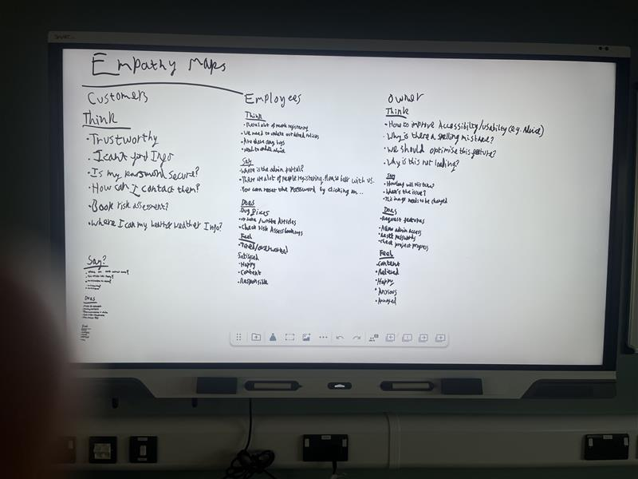
Customers

Thinks
- How do I book a risk assessment?
- I hope this website is trustworthy
- Is this information correct, I’ve seen people say different about this
- I want to register so I can view personalised health advice
- Why is this page not loading?
- Help! I forgot my password!
- I can’t attend my risk assessment, I need to cancel it
- This charity sounds amazing
- I hope I don’t have to pay for the risk assessment
- I need help with my asthma, I hope it has articles on {subject}

Says
- How do I search for an article?
- What information does the website take from me?
- Will I be able to cancel my risk assessment?
- This new digital solution looks great!
- Do you have articles about asthma?

Does
- Books a risk assessment
- Makes an account
- Deletes an account
- Logs into an account
- Resets their password
- Reads the terms and conditions
- Searches for articles on asthma
- Checks for air quality in their area

Feels
- Helpful
- Content
- Optimistic
- Confused
- Relieved
- Anxious

Functional and Non-functional Requirements

Functional Requirements
- Provide users with health advice
- Provide information on environmental health conditions and seasonal allergies
- Home page
- Register page
- Login page
- About us page
- Policy page
- Terms and Conditions page
- Weather forecasting
- Dashboard showing air quality of weather
- Admin portal
- The solution must have a fixed layout for every article
- The solution must have admin accounts already set up
- There should be a navigation bar
- The solution should have the navigation bar on every page
- There should be a footer on every page

Non-functional Requirements
- Weather forecasting for advice personalised to the weather conditions
- Follow WCAG guidelines
- Accessibility panel
- Aesthetically pleasing interface
- Location tracker for basing advice on the weather (optional)
- Input validation on register form
- Input validation on login form

Hierarchy Diagram

Decomposition of Potential Problems
- Admin dashboard doesn’t load – admins will be unable to view site statistics
- Weather API doesn’t respond – the app will be unable to give advice based on the weather
- Poor usability
- Poor accessibility (e.g., no Alt text)

Creating the solution
- Not enough resources – can delay the time it takes to develop and release the project
- Not enough time for development – project may be rushed and/or incomplete
- Errors in the solution – can create more errors trying to solve them and can contribute to an unfinished solution
- Not enough knowledge – can cause delay in releasing the program, or releasing an unfinished solution

Layout
- Page styling isn’t consistent – users may get confused, customer might instead go to a competitor’s website, loss of a customer
- Page design isn’t responsive – the website may look broken to users (e.g., on mobile), customers might instead go to a competitor’s website, loss of a customer
- Images won’t load – the website may look broken to users, customers might go to a competitor’s website, loss of a customer

Viewing Articles
- Page doesn’t load – customer might instead go to a competitor’s website, loss of a customer
- Can’t find a specific article – customer might switch to a competitor that does have the article they’re looking for
- Page doesn’t load as it should (unresponsive to different screen sizes) – customer might instead go to a competitor, bad review of the website
- Article has outdated information (not reliable) – customer can be misinformed, bad review of the website

Booking Risk Assessments
- Page doesn’t load – customer might instead go to a competitor’s website, loss of a customer
- Customer entered wrong information and can’t go back – customer might not attend the risk assessment after this, bad review of the website if they can’t go back and change details
- Customer doesn’t know how to cancel a risk assessment – empty booked appointment (slot taken), risk assessment professional might waste time waiting for the customer, customers who want an assessment cannot as the slot is already taken

Accounts
- User forgot their password and can’t reset it – the user won’t be able to book risk assessments, customer may go to a competitor’s website, loss of a customer
- User can’t register – customer might instead go to a competitor’s website, loss of a customer

Legal
- Images may be copyrighted – can lead to the image being taken down, the copyright owner may impose penalties, loss of income

Justification of How Potential Risks Will be Mitigated

Creating the solution
- Not enough resources – plan how many resources the project will need
- Not enough time for development – plan and estimate the time the project will take
- Errors in the solution – plan for errors in the solution, hardest functions to code
- Not enough knowledge – plan and prepare for what knowledge might need to be used

Layout
- Page styling isn’t consistent –
- Page design isn’t responsive –
- Images won’t load – test the pages for this function and make sure there is nothing that is increasing the time of the response

Viewing Articles
- Page doesn’t load – test the pages for this function and make sure there is nothing that is increasing the time of the response
- Can’t find a specific article – add search and filter options so the customer can filter for articles
- Page doesn’t load as it should (unresponsive to different screen sizes) – test the page to be responsive on all devices before deployment
- Article has outdated information (not reliable) – update article information every 6 months to make sure its updated

Booking Risk Assessments
- Page doesn’t load – test the pages for this function and make sure there is nothing that is increasing the time of the response
- Customer entered wrong information and can’t go back –
- Customer doesn’t know how to cancel a risk assessment –

Accounts
- User forgot their password and can’t reset it –
- User can’t register –

Legal
- Images may be copyrighted –

Description of the proposed solution

Navigation Bar
The solution will have a navigation bar which will be present at the top of every page. The navigation bar will contain links to the other pages on the site, including the Homepage, About Us, Login/Register, Terms & Conditions, as well as the icon and page title. Styling and positioning of the navigation bar will remain consistent with it being at the top of every page – Consistent positioning of the navigation bar will help users use the solution more easily as they know that navigation tools will remain in the same location on every page. Additionally, consistent styling of the navigation bar.

Accessibility
The solution will have an accessibility panel which will be present in the same place on the right side of every page. The accessibility panel will be easily viewable and have options for changing font size, font colour, reducing motion.

Home Page
The homepage will be the first page that users see when they use the solution, this page will contain a description of the purpose of the solution and features it has, as well as descriptions of and links to the other pages of the solution.

About Us Page

Login/Register Page
The accounts page will include both a form for creating an account, and another for logging into accounts. On mobile (or other devices with smaller screens) these forms will be combined into one with an added button to switch between the two.

Policy/Terms & Conditions Page
The policies and terms & conditions page will contain legal information…

Articles pages
There will be an advice page, featuring different articles in the same layout. The user will be able to change the pages (skip a few or go back a few pages), filter for pages which will change the icon colour and search for a specific article – The advice page has the same layout so customers can guess where the next article is located so it’s very easy to read and organised which looks more professional. The filter feature, switch page feature, and search feature all make the website more customisable for different audiences since they offer different methods on how to find the article that the customer needs. This is very user friendly.

Key Performance Indicators (KPIs)

What KPIs should be measured?
- Page response time
- Uptime
- Air quality data
- Weather data per region
- How many people sign up? (weekly)
- How many people delete their accounts? (monthly)
- Website abandonment rate (people who start doing something but stop doing it)
- Number of logins (daily)
- User location data (where do most users access the site from?)
- Number of active users monthly
- Number of inactive users
- Number of requests per API
- API response times
- Number of people using accessibility settings (weekly)
- How many attacks against the site have occurred? (monthly)
- Resource usage (CPU, RAM, disk, network)
- Devices used to access the site? (mobile, desktop)
- Most viewed/accessed articles (pages) (monthly)
- Number of appointments booked (weekly)
- Number of appointments cancelled (weekly)
- How many articles have been written (lifetime, weekly)
- Number of articles read (weekly)

User Acceptance Criteria
- Pages should load quickly and efficiently
- Home page must exist
- Accessibility options must exist
- Navigation bar – links to more pages
- Article search page
- Dashboard
- Consistent styling
- Responsive design

Layout
- ???

Home Page
- The user can view the home page and interact with it
- The customer must be able to view the weather forecast after accepting cookies
- The customer can view the newest articles on the home page and click on one which will redirect them to the article
- The weather forecast will be accurate to the user’s location
- The weather forecast layout will always remain the same

Articles Page
- Every article should have consistent styling and layout

Weather Page
- ???

Accounts Page
- ???

Policy Page
- There will be text covering all policies

Terms and Conditions Page
- ???

About Us Page
- History
- Images
- Contact details
- Enquiry page

Justification of How Legal Requirements Will Be Addressed
The relevant regulatory guidelines will be met by incorporating an accessibility panel to follow the WCAG 2.1 guidelines which provide accessibility and usability for people with on different devices, and it will be saved using their IP in the database. GDPR guidelines will be followed by prompting the user to accept or deny cookies and having a terms and conditions page which will explain to users and customers how the charity uses data to enhance the user’s experience. When customers try to sign up for the website, they will have to accept the terms and conditions before they can sign up.

Hardware and Software

Hardware

Clients
- Computer (desktop, laptop)
- Phone

Developers
- Good computer to develop the code on
- Powerful server to host the website

Software

Clients
- Operating system (e.g., Windows, Mac OS, Linux, iOS, Android)
- Web browser (e.g., Chrome, Edge, Firefox, Safari)

Developers
- Visual Studio Code – used to write the code as it provides syntax highlighting and auto formatting
- PG Admin
- FileZilla
- Draw.io – used to create diagrams (e.g., flowcharts)
- Access (database client)
- Canva or Figma – used to create mock-up designs of the website
- SQL – the language used to interface with the database
- PHP – to develop the back-end of the solution
- JavaScript – used for making the client-side interactive elements work (e.g., drop-down menus)
- HTML – the document that is rendered by the client’s web browser, contains definitions for buttons, text, links, etc
- CSS – used to style the rendered HTML document

Appendix

Emerging Technologies
- Artificial Intelligence (AI):
  - AI can be used to make predictions on weather patterns based on previous data
  - AI chatbots can be us
- Internet of Things (IoT) – wearable devices such as smart watches that are used to track and monitor health information (e.g., heart rate, blood pressure, blood oxygen)

